1. Using a PLSQL block, raise with 10% the salary of the employees who work in the same department as employee 115. Display how many employees got the raise

SET SERVEROUTPUT ON

begin

update EMPLOYEES set SALARY=SALARY*1.1

where DEPARTMENT_ID = (select DEPARTMENT_ID from EMPLOYEES where EMPLOYEE_ID = 115);

if sql%notfound then dbms_output.put_line('NO SALARIES CHANGED');

else dbms_output.put_line(SQL%ROWCOUNT||' SALARIES HEVE BENN MODIFIED');

end if;

end;

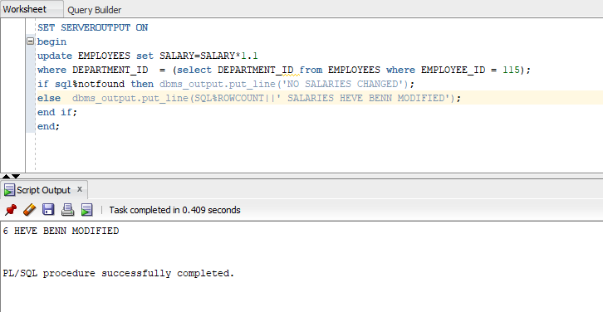

1. Using a cursor, display the last five employees according to their HIRE_DATE

declare

cursor c is select * from EMPLOYEES order by HIRE_DATE asc;

r c%rowtype;

NO_EMPLOYEES number(5):=0;

begin

for r in c loop

dbms_output.put_line('EMPLOYEE '||r.FIRST_NAME||' '||r.lAST_NAME|| ' HIRED IN DATE '||r.HIRE_DATE||' HAS THE SALARY '||r.SALARY);

NO_EMPLOYEES := NO_EMPLOYEES+1;

if NO_EMPLOYEES = 5 then

exit;

end if;

end loop;

end;

